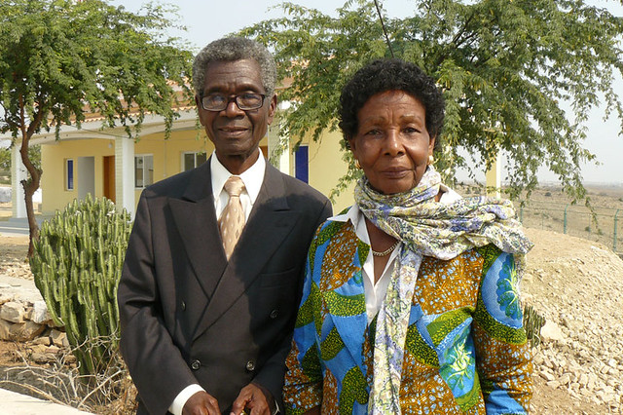
José and Eva Chipenda

 | Journal of African Christian Biography  Quarterly publication of the Dictionary of African Christian Biography  Sign up for a free subscription at https://dacb.org/journal/ | DONATE
Journal of  African  Christian  Biography | Vol. 8, No. 4 (Oct 2023)  Focus: Ecumenists
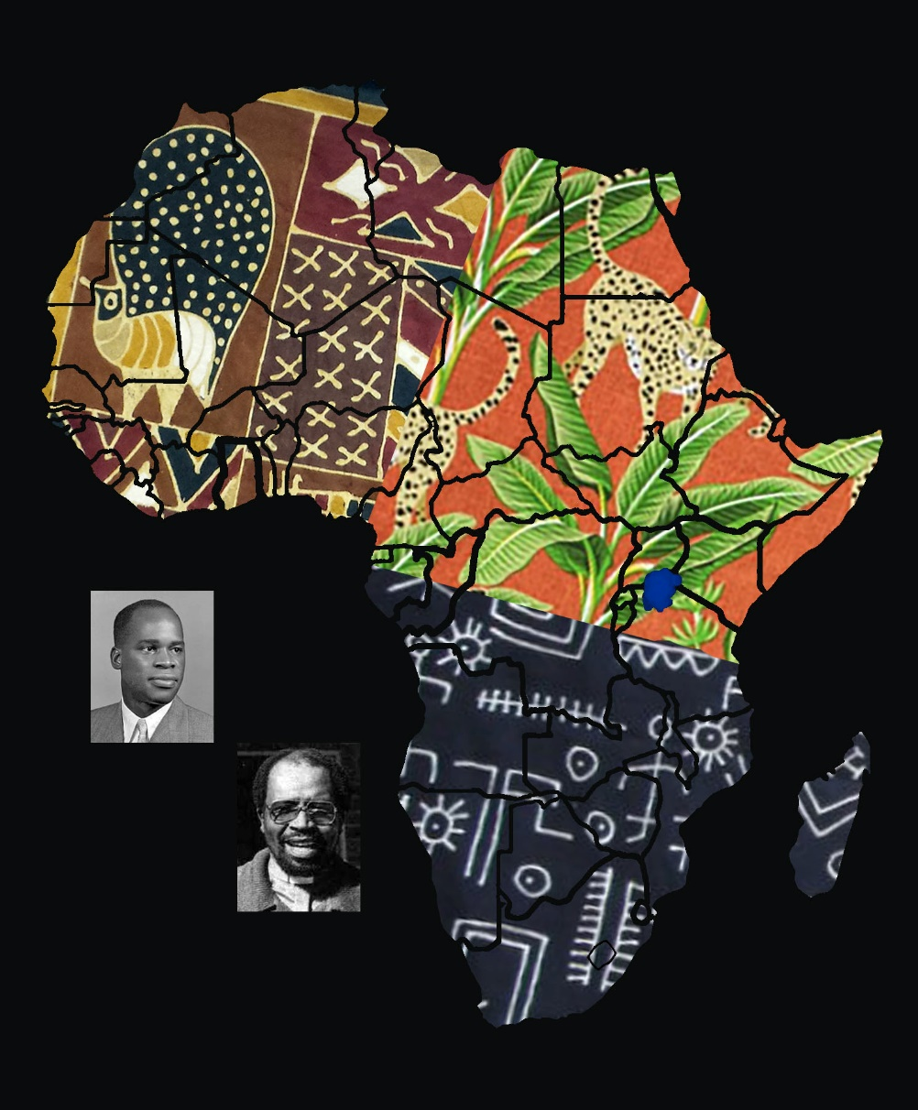
A publication of the Dictionary of African Christian Biography

