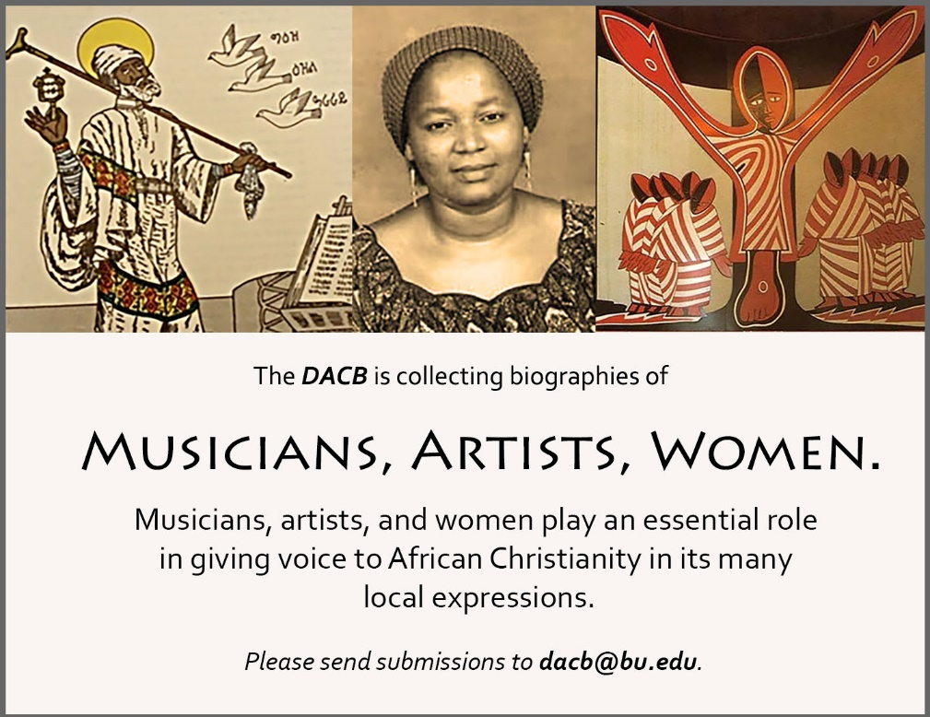

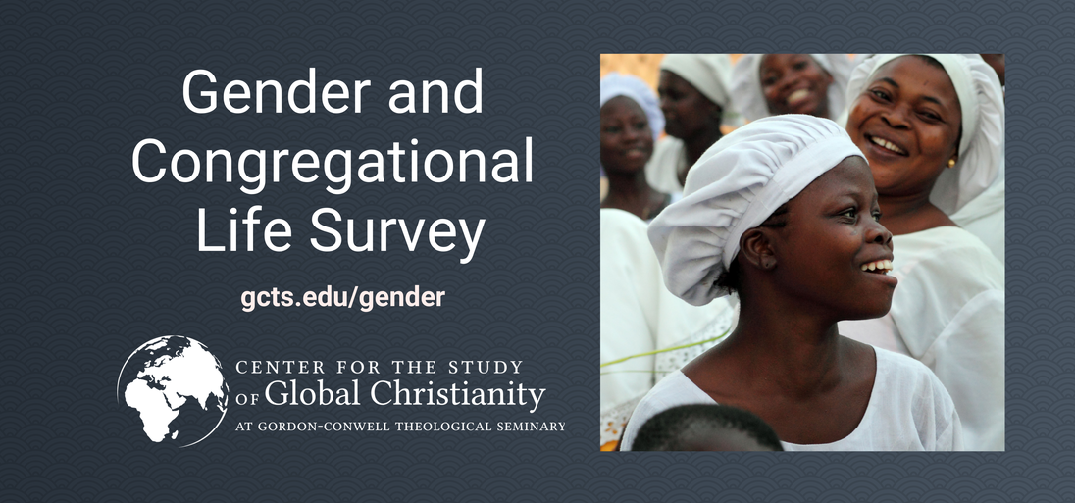
Click here to take this survey.
COVER PHOTO (Credit G. L. Allen): Georgetown Methodist Church, Janjangburay, MacCarthy Island, The Gambia, built and dedicated in 1833, the oldest Wesleyan Methodist Church South of the Sahara Desert in Africa

Journal of  African  Christian  Biography | Vol. 6, No. 2 (April 2021)  Focus: The Gambia:  200 Years of Wesleyan Methodist Missions; Morgan, Baker, Fox,  Cupidon, Sallah
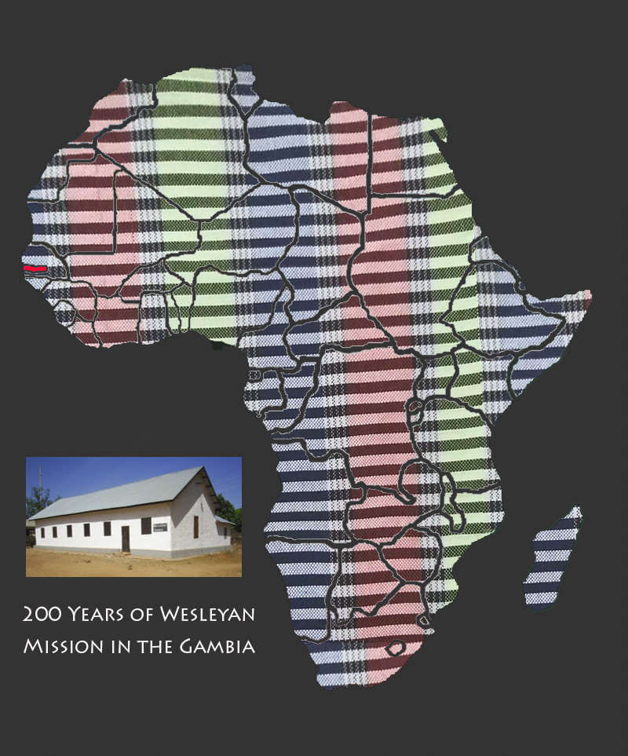
A publication of the Dictionary of African Christian Biography

