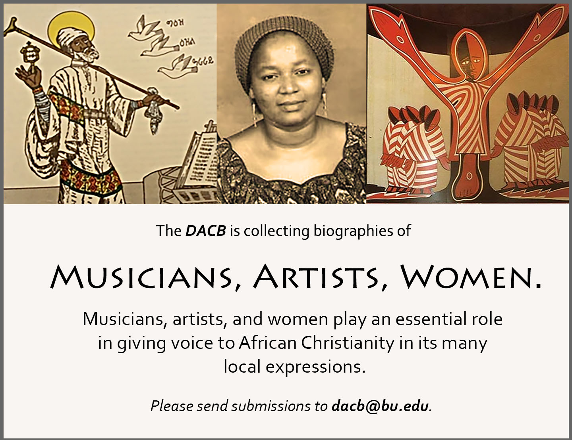

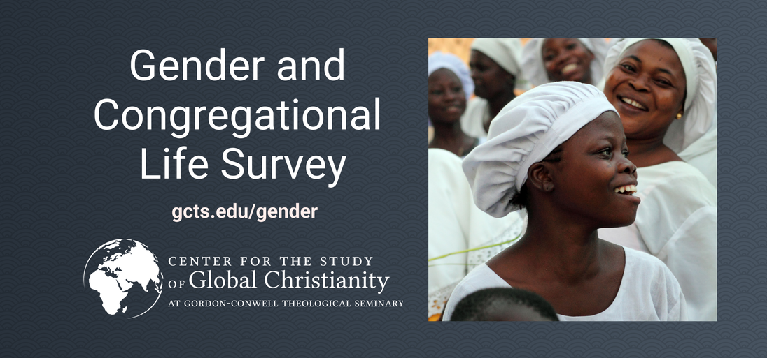
See inside for more details on this survey.

Journal of  African  Christian  Biography | Vol. 6, No. 1 (Jan. 2021)  Focus:  George Arthur Gatungu Gathuna (Kenya); Philip Kwabi and Daniel Saba (Gold Coast); Casely Essamuah (interview)
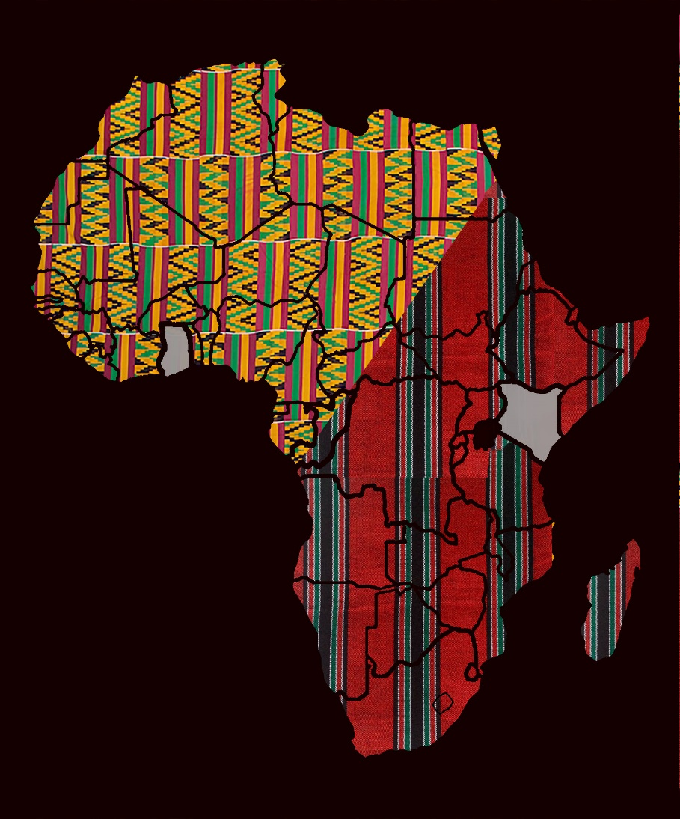
A publication of the Dictionary of African Christian Biography

