COVER PHOTO: “Prof.” Andrew Walls (1928-2021), courtesy of James Krabill, Facebook

Journal of  African  Christian  Biography | Vol. 6, No. 4 (Oct. 2021)  Focus: Tributes to Andrew Walls and Benedict Ssettuuma (Uganda); Samuel T. O. Akande (Nigeria)
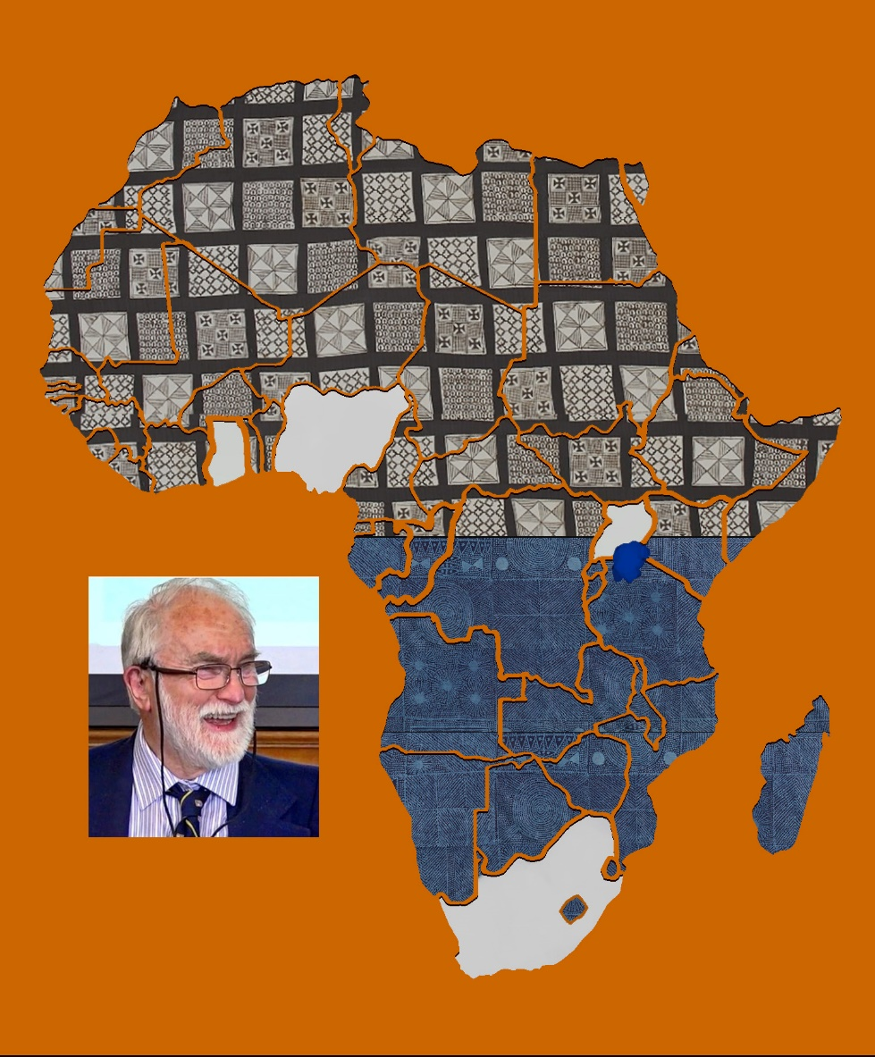
A publication of the Dictionary of African Christian Biography

