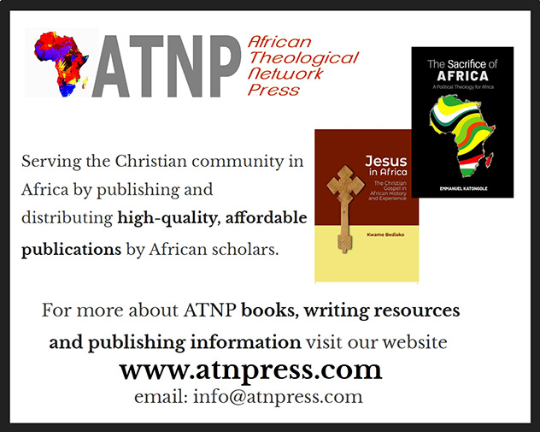
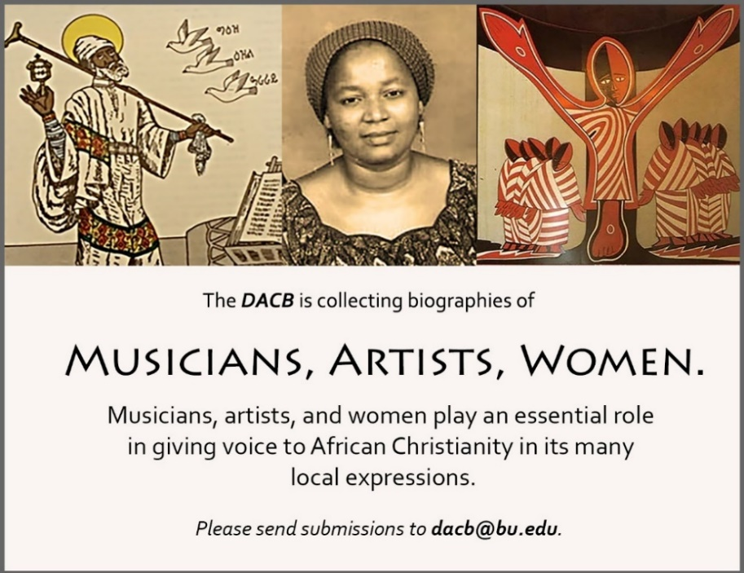

Subscribe to the JACB at www.dacb.org/journal/
Journal of  African  Christian  Biography | Vol. 5, No. 2 (April 2020)  Focus: WOMEN / BILINGUAL (FRENCH)  Nokutela Dube (S. Africa), Émilienne Moungou-Mouyabi (Congo)  Tribute to John S. Pobee (Ghana)

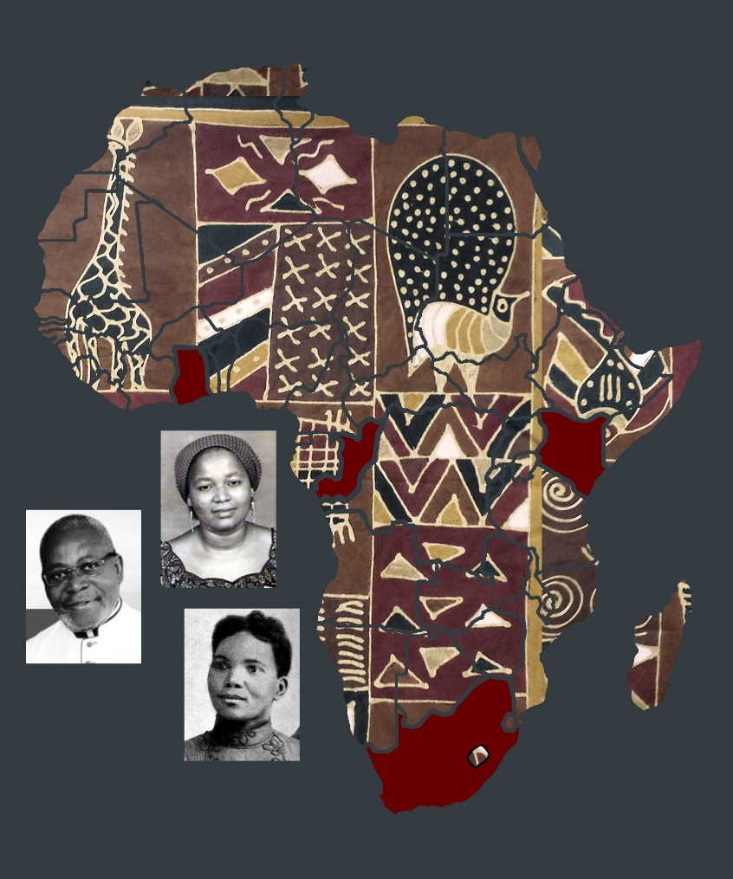
A publication of the Dictionary of African Christian Biography

