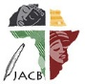 | Journal of African Christian Biography  Quarterly publication of the Dictionary of African Christian Biography  Sign up for a free subscription at https://dacb.org/journal/ | DONATE
Journal of  African  Christian  Biography | Vol. 9, No. 1 (Jan 2024)  Focus: Early African Christianity  Quodvultdeus of Carthage; Hadian of Canterbury; Giyorgis of Salga;  T. Oden and CEAC; A. Walls; L. Sanneh
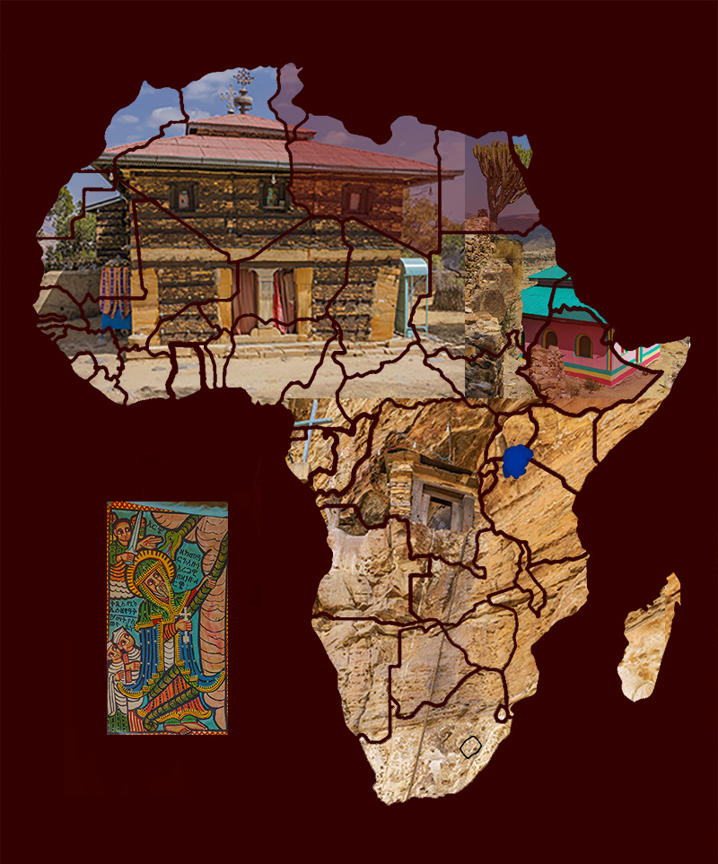
A publication of the Dictionary of African Christian Biography

