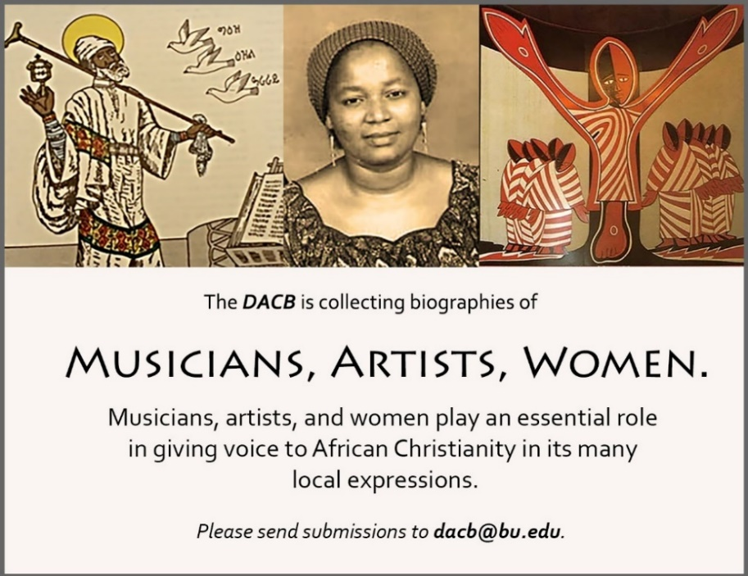

Subscribe to the JACB at www.dacb.org/news/journal/
Journal of  African  Christian  Biography | Vol. 4, No. 3 (July 2019)  Focus:  I. Ababio and C. Y. Yeboa-Korie (Ghana)  James Cone Tribute  Reviews: African Christian Biography and the Africa Study Bible
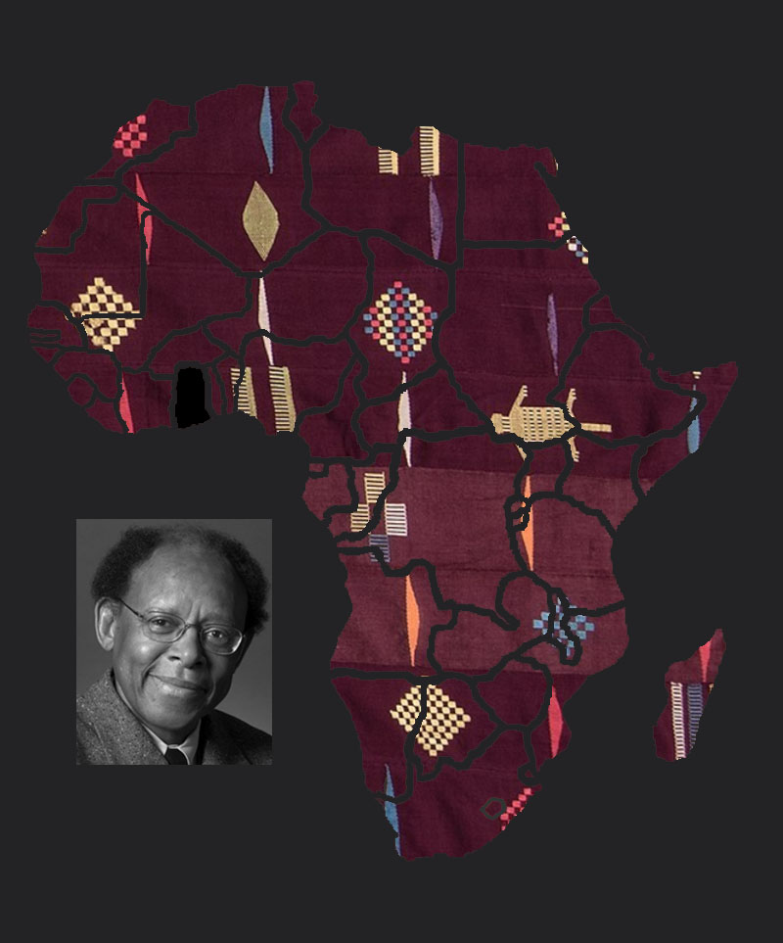
A publication of the Dictionary of African Christian Biography

