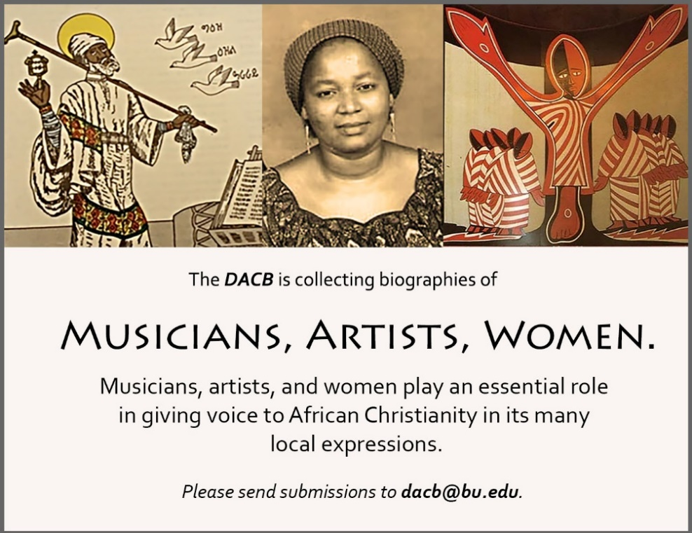
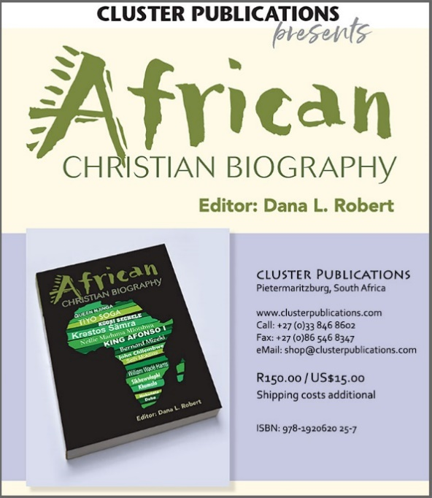 | 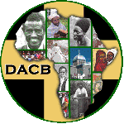  www.DACB.org  Send biographies of any African men and women, clergy and lay people who served as the founders and builders of Christian communities in Africa to:  Michèle Sigg  Associate Director dacb@bu.edu

Subscribe to the JACB at www.dacb.org/news/journal/
Journal of  African  Christian  Biography | Vol. 4, No. 1 (Jan. 2019)  Focus:  African Christian Biography  Musicians and Composers:  Yared, John Knox Bokwe
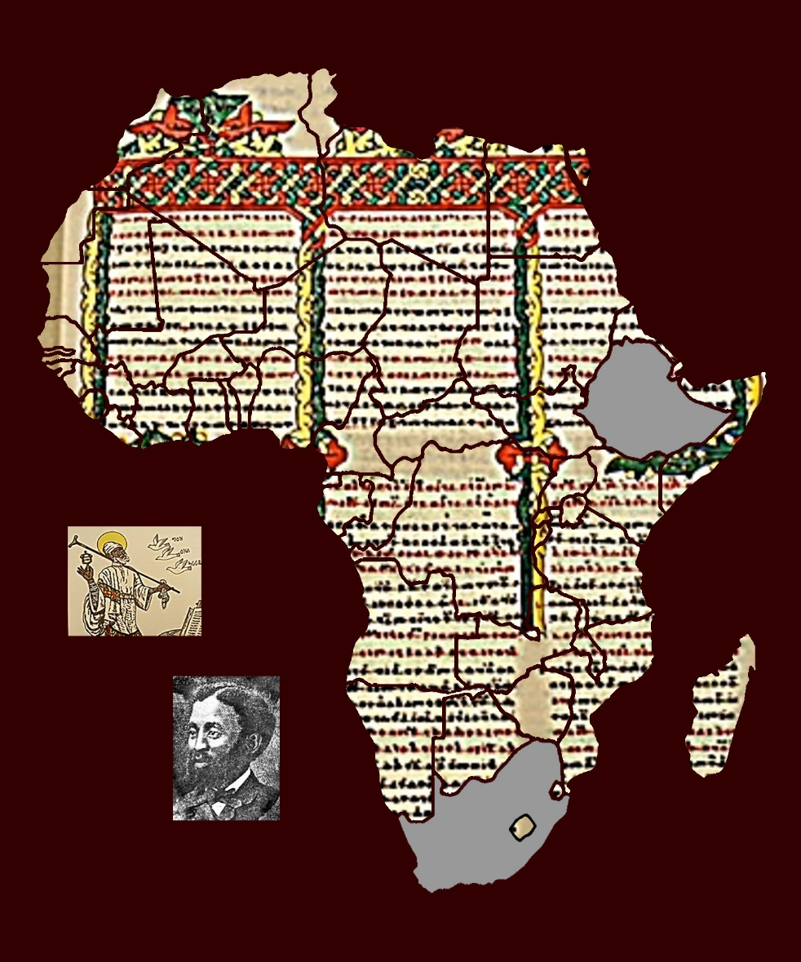
A publication of the Dictionary of African Christian Biography

