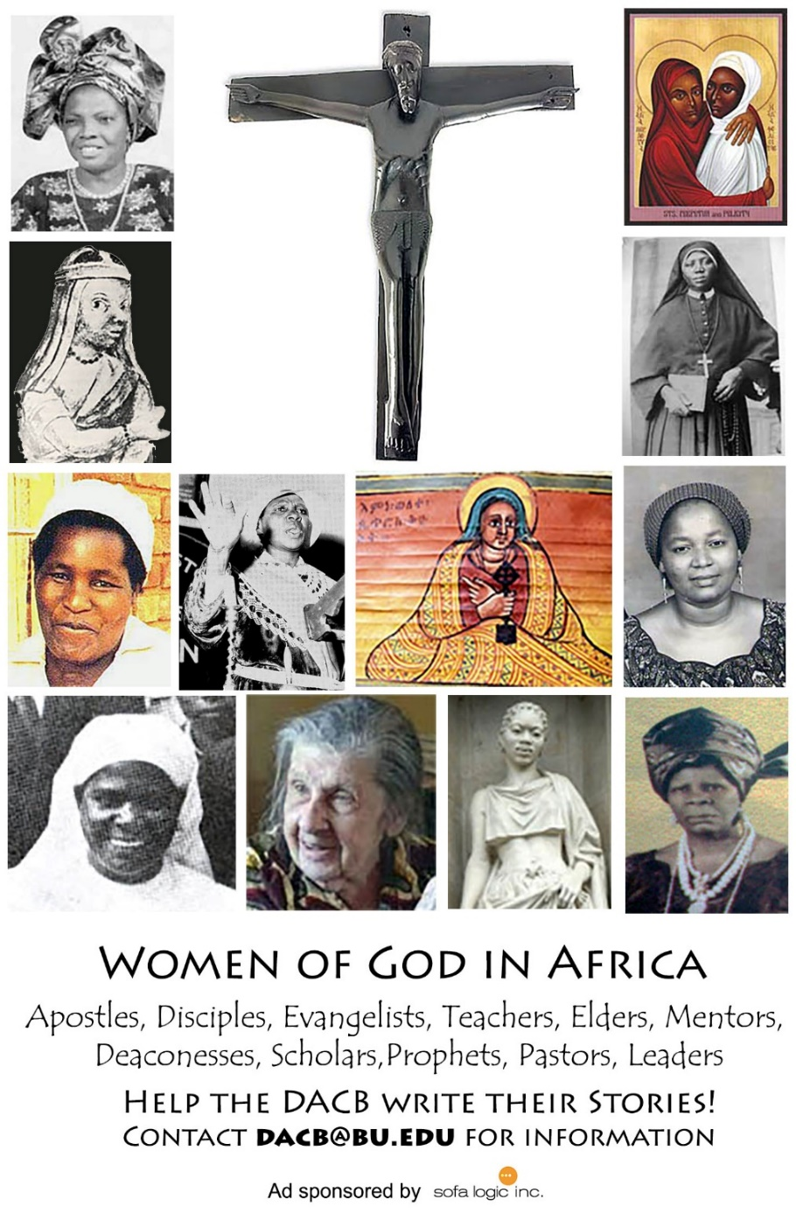

Journal of  African  Christian  Biography | Vol. 3, No. 2 (April 2018)  Focus:  Samuel Mutendi  (Zimbabwe)  Paul Nchoji Nkwi (Cameroon)
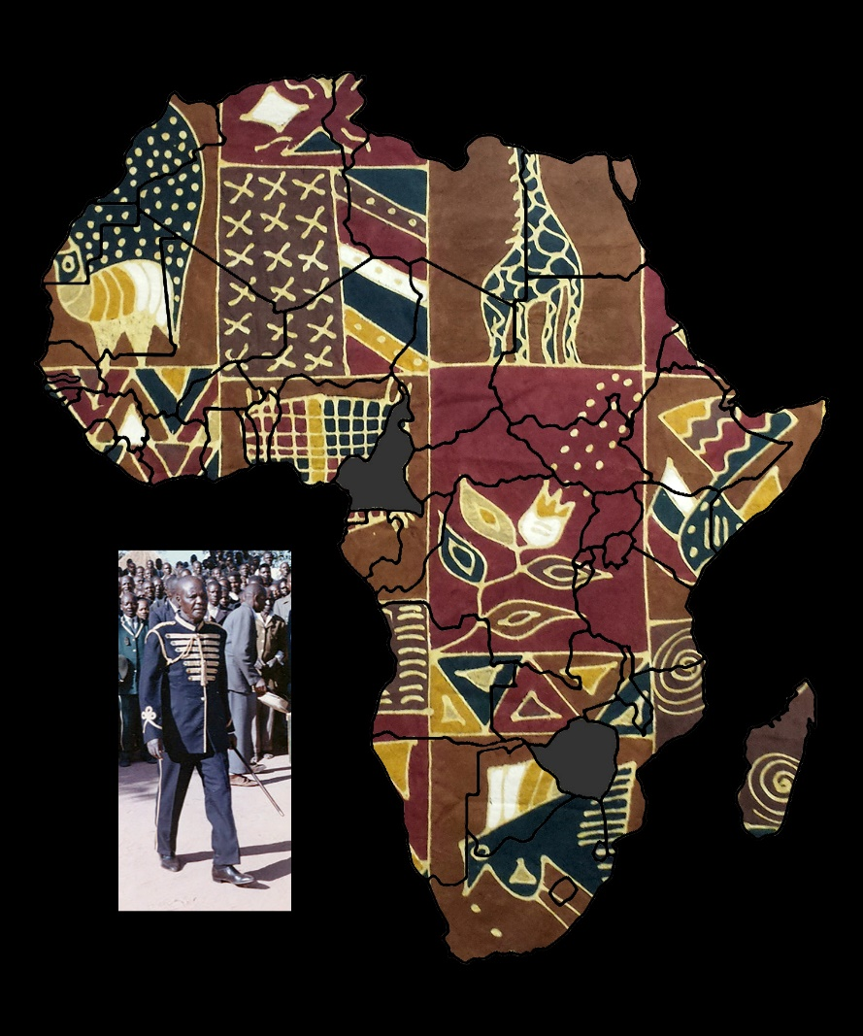
A publication of the Dictionary of African Christian Biography

