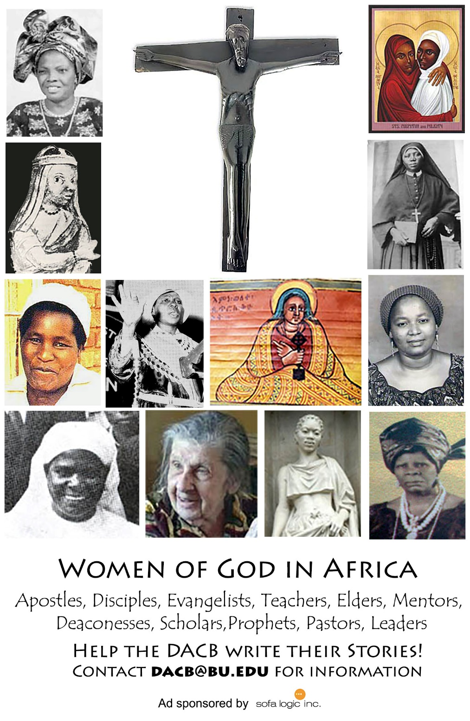

Journal of  African  Christian  Biography | Vol. 2, No. 4 (Oct 2017)  Focus:  Bernard Mizeki (Zimbabwe)  Manche Masemola & A. Luthuli (S. Africa)  Bethuel Kiplagat
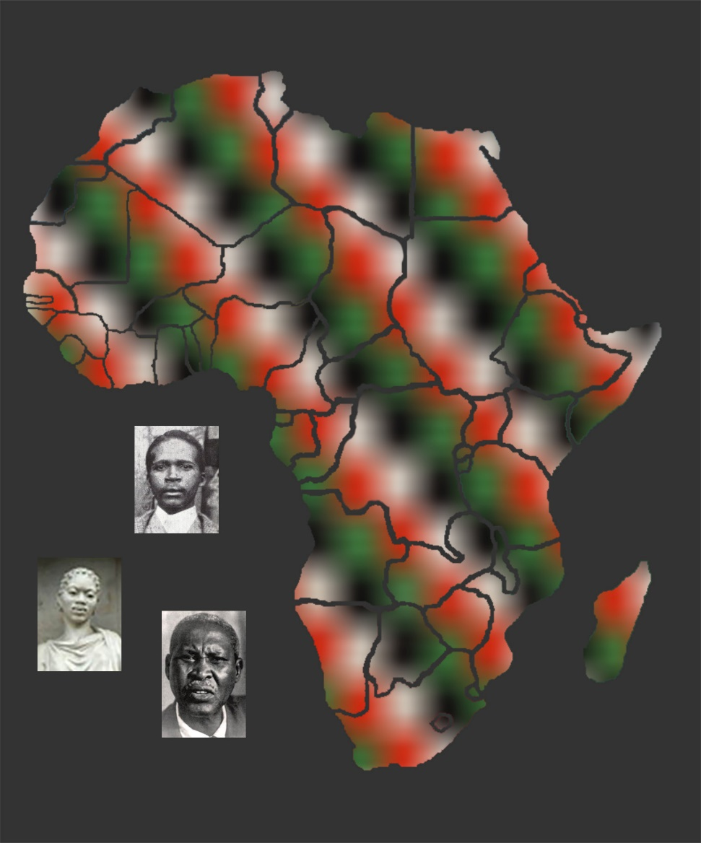
A publication of the Dictionary of African Christian Biography

