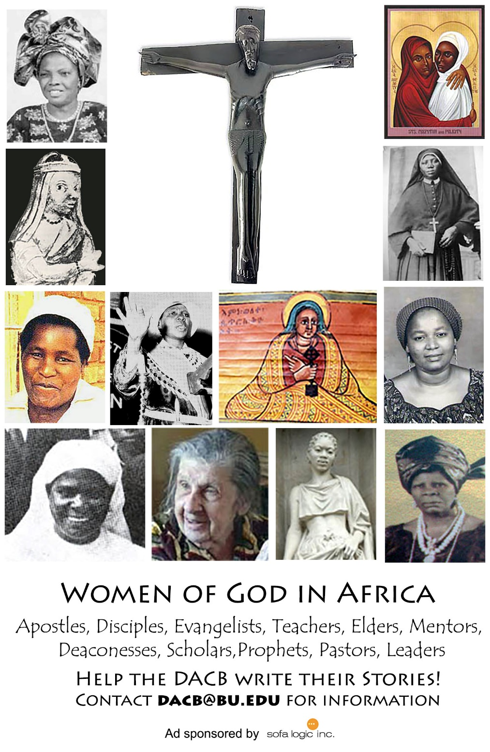

Journal of  African  Christian  Biography | Vol. 2, No. 3 (July 2017)  Focus:  Agnes Okoh (Nigeria)  Kivebulaya, Luwum, Njangali (Uganda)  Lamin Sanneh
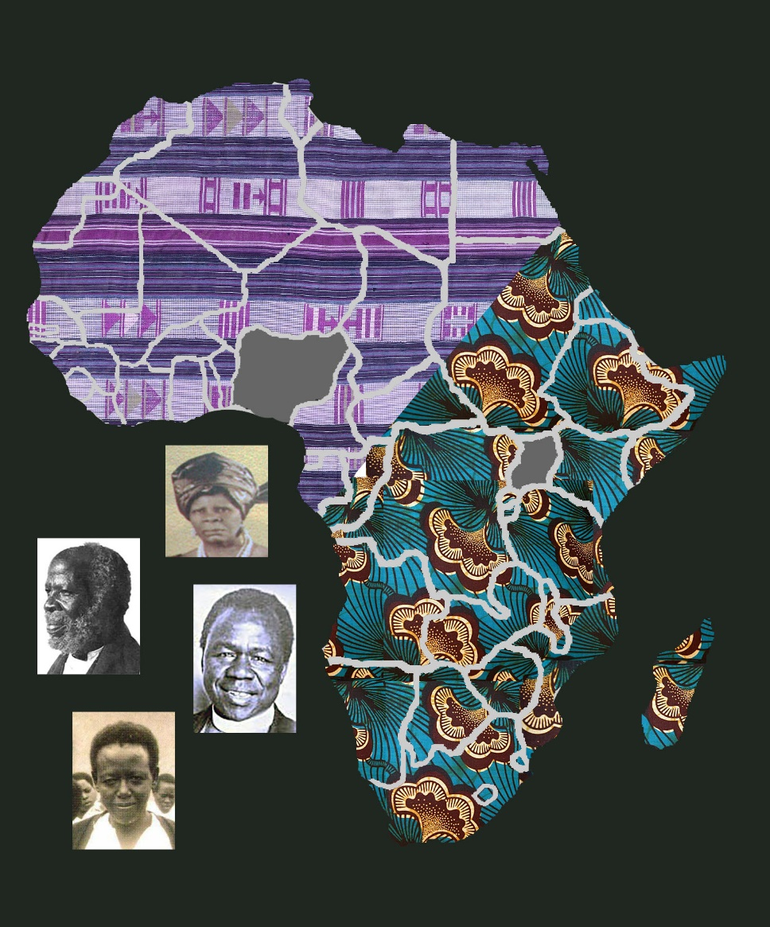
A publication of the Dictionary of African Christian Biography

