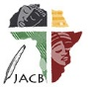 | Journal of African Christian Biography  Quarterly publication of the Dictionary of African Christian Biography  Sign up for a free subscription at https://dacb.org/journal/ | DONATE
Journal of  African  Christian  Biography | Vol. 8, No. 3 (July 2023)  Focus: Catechists and Evangelists  J. E. Sarbah (Ghana), Sembera Mackay (Uganda), Jerusha Kanyua (Kenya)
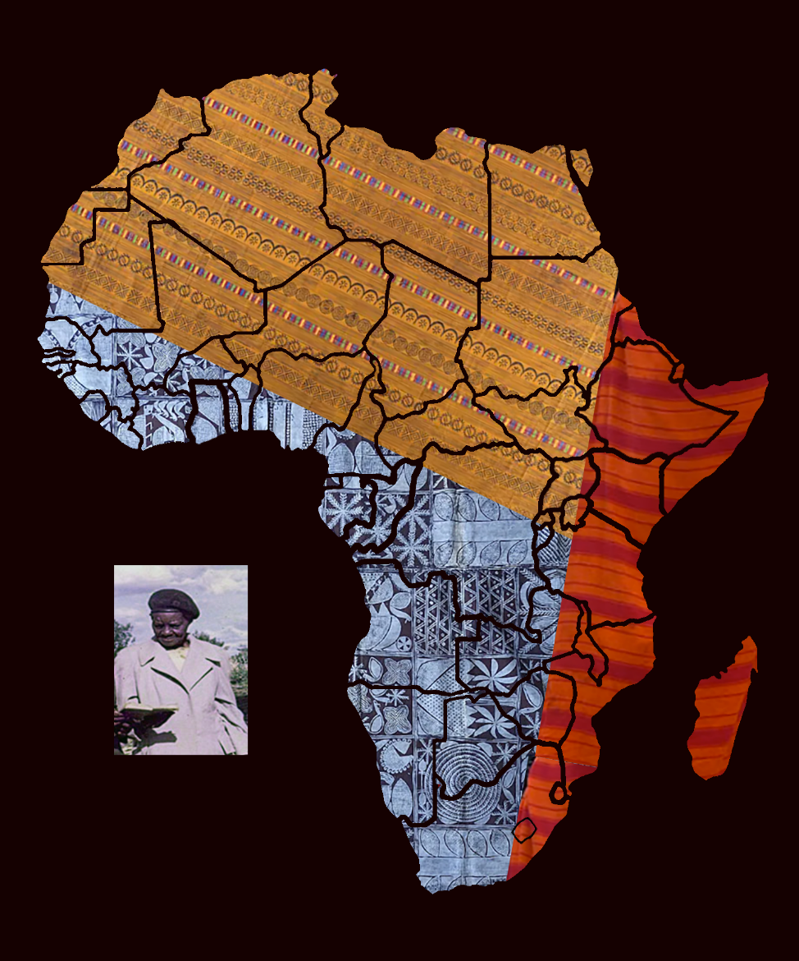
A publication of the Dictionary of African Christian Biography

