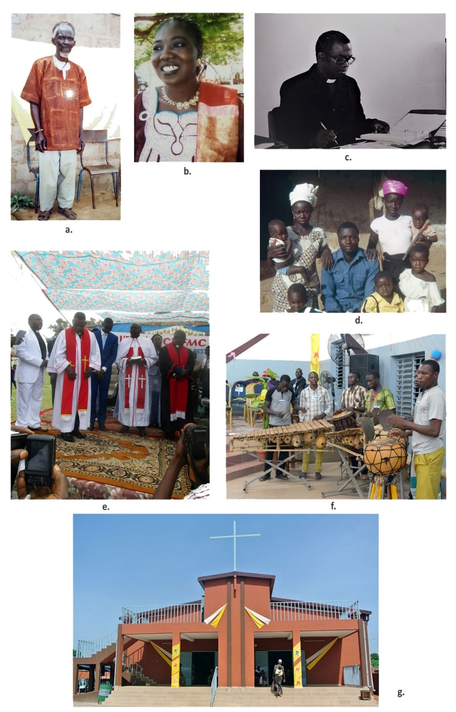
Journal of  African  Christian  Biography | Vol. 7, No. 2/3 (Apr-July 2022)  Focus: Anabaptist-Mennonite Movement in Africa  DOUBLE ISSUE  BILINGUAL (ENGLISH)
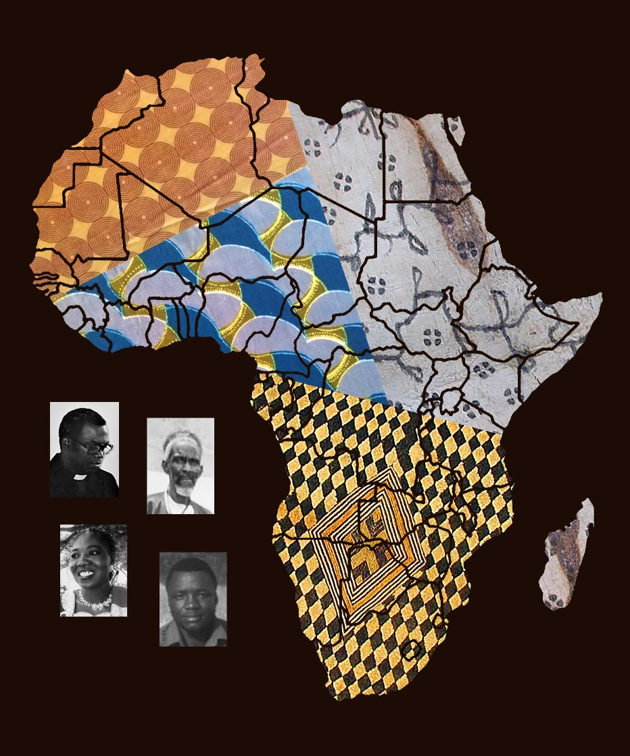
A publication of the Dictionary of African Christian Biography

