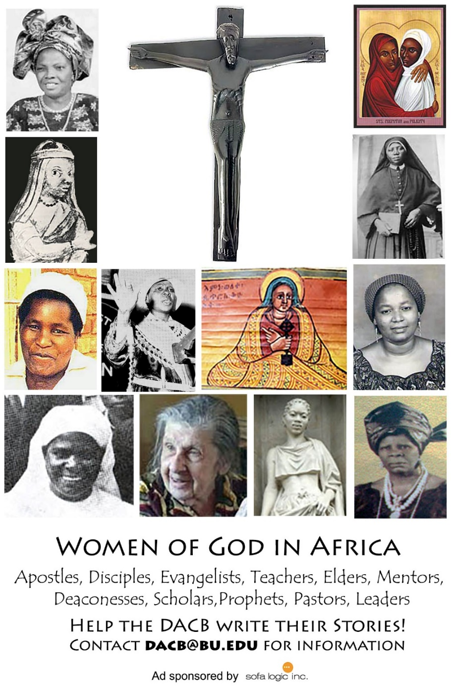

Journal of  African  Christian  Biography | Vol. 3, No. 4 (Oct 2018)  Focus:  P. D. Zakayo Kivuli (E. Africa)  Aladura Trailblazers, Successors (Nigeria)
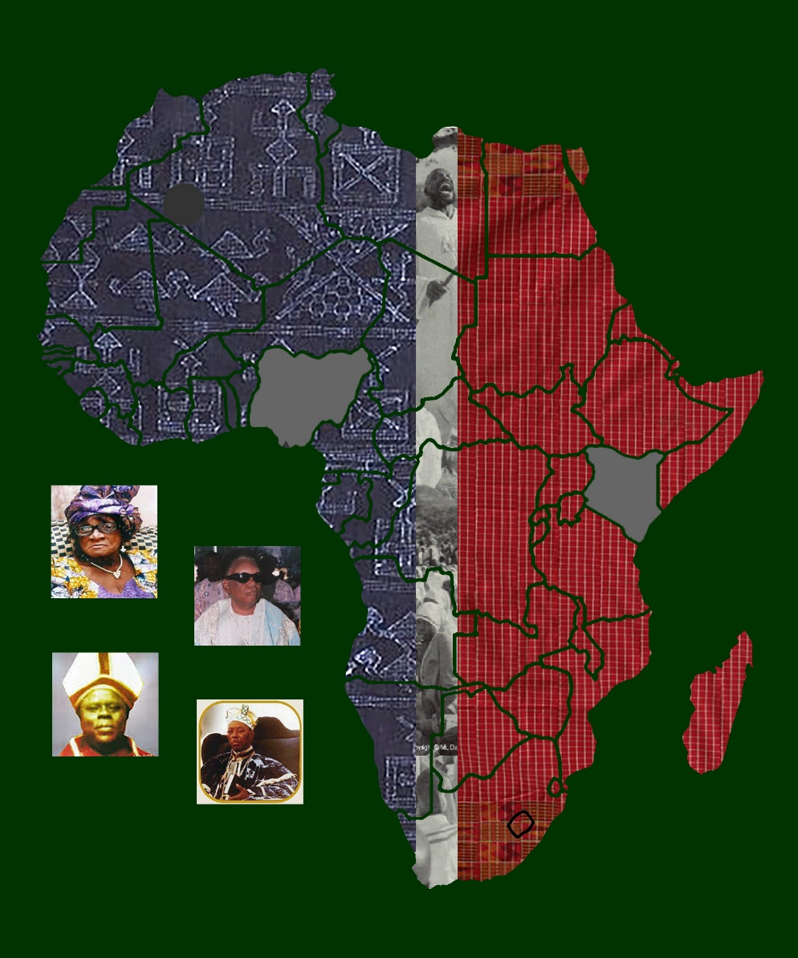
A publication of the Dictionary of African Christian Biography

