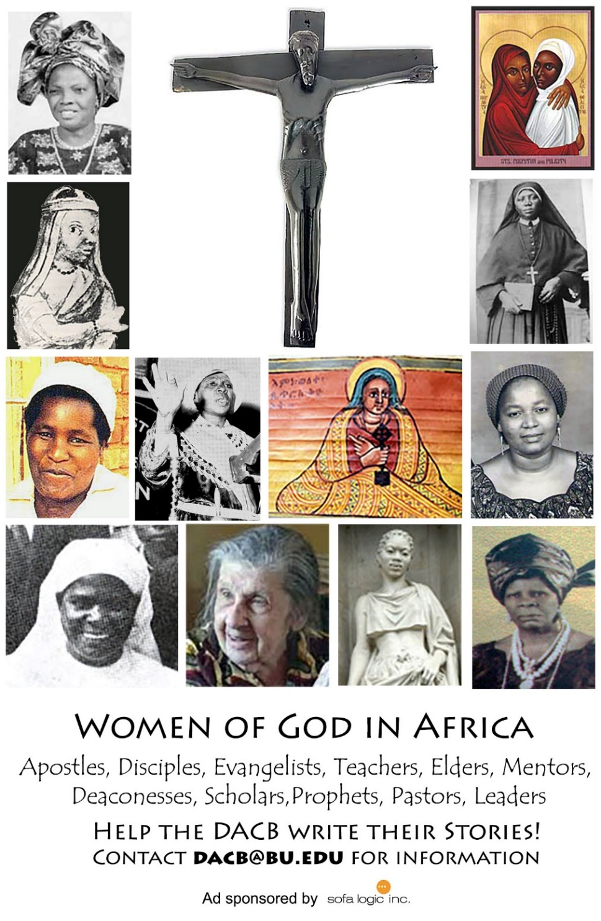

Journal of  African  Christian  Biography | Vol. 3, No. 1 (Jan 2018)  Focus:  Horton, Nicol, Maxwell, Richards  (The Gambia)  Daniel Williams Alexander (East Africa)
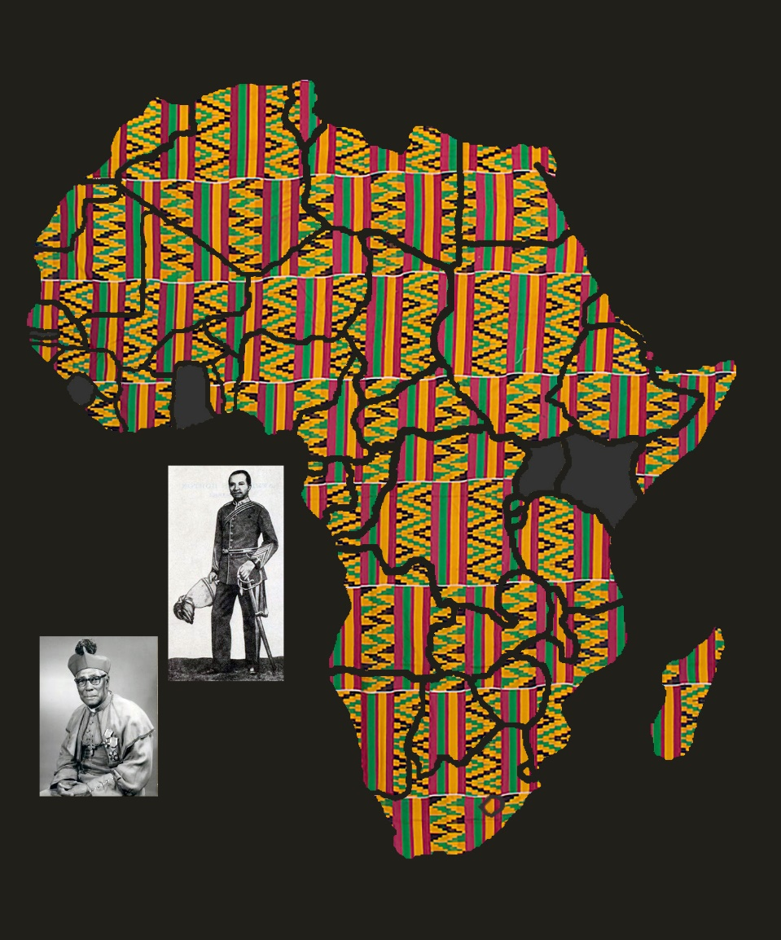
A publication of the Dictionary of African Christian Biography

